College Portal

Analysis and Design Document

Student: Raul-Mihai Acu

**Group: 30432**

Revision History

|  |  |  |  |
| --- | --- | --- | --- |
| **Date** | **Version** | **Description** | **Author** |
| 21/03/2018 | 1.0 | Vision, Use-Case Model, Glossary, Supplementary Specification | Acu Raul-Mihai |
| 05/04/2018 | 2.0 | Domain Model, Architectural Design, Component diagram | Acu Raul-Mihai |
| 25/04/2018 | 3.0 | Design Model, Data model | Acu Raul-Mihai |
| 30/05/2018 | 4.0 | Final | Acu Raul-Mihai |

Table of Contents

I. Project Specification 4

II. Elaboration – Iteration 1.1 4

1. Domain Model 4

2. Architectural Design 5

2.1 Conceptual Architecture 5

2.2 Package Design 6

2.3 Component and Deployment Diagrams 6

III. Elaboration – Iteration 1.2 7

1. Design Model 7

1.1 Dynamic Behavior 7

1.2 Class Design 7

2. Data Model 8

3. Unit Testing **Error! Bookmark not defined.**

IV. Elaboration – Iteration 2 **Error! Bookmark not defined.**

1. Architectural Design Refinement **Error! Bookmark not defined.**

2. Design Model Refinement **Error! Bookmark not defined.**

V. Construction and Transition **Error! Bookmark not defined.**

1. System Testing **Error! Bookmark not defined.**

2. Future improvements **Error! Bookmark not defined.**

VI. Bibliography 9

# Project Specification

The College Portal application will provide means of communication between students and teachers, announcements, information regarding activities or events related to their college, and also access to their profiles, grades or payments.

# Elaboration – Iteration 1.1

# Domain Model

A domain model is a system of abstractions that describes selected aspects of a sphere of knowledge, influence or activity . The model can then be used to solve problems related to that domain. The domain model is a representation of meaningful real-world concepts pertinent to the domain that need to be modelled in software. The concepts include the data involved in the business and rules the business uses in relation to that data.

A domain model generally uses the vocabulary of the domain, thus allowing a representation of the model to be communicated to non-technical stakeholders.

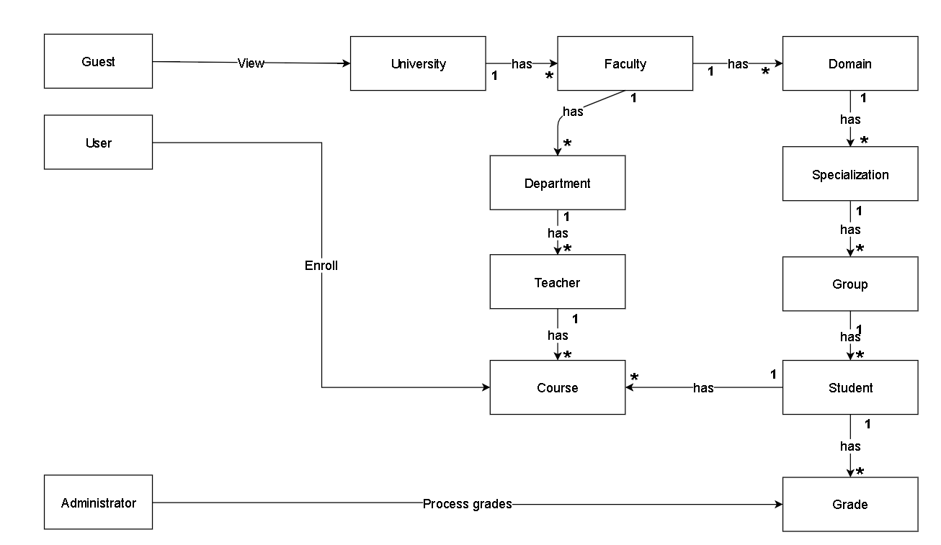

# Architectural Design

## Conceptual Architecture

Conceptual architecture is a form of architecture that utilizes conceptualism, characterized by an introduction of ideas or concepts from outside of architecture often as a means of expanding the discipline of architecture. This produces an essentially different kind of building than one produced by the widely held 'architect as a master-builder' model, in which craft and construction are the guiding principles. The finished building as product is less important in conceptual architecture, than the ideas guiding them, ideas represented primarily by texts, diagrams, or art installations.

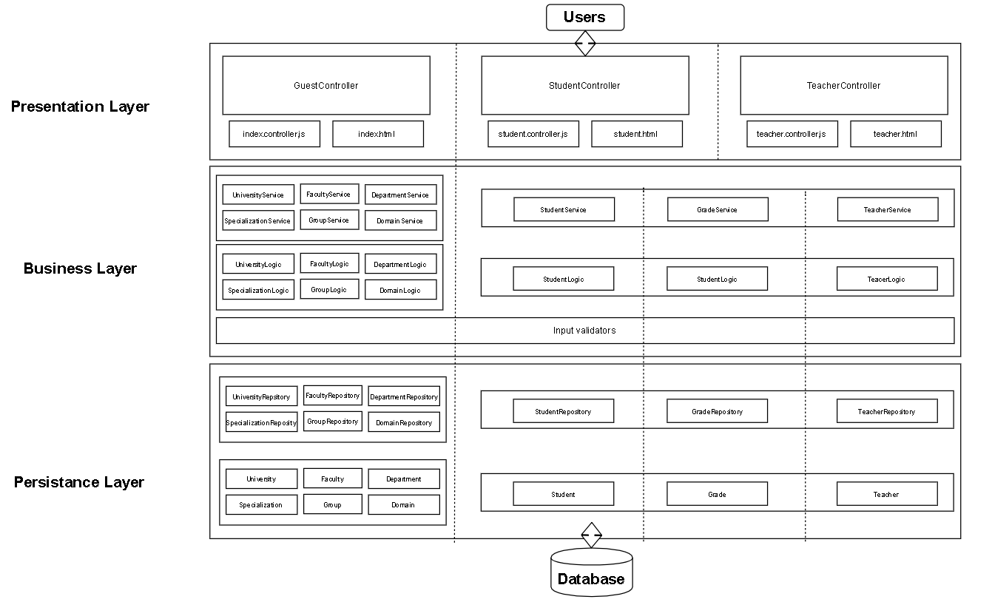

## Package Design

## 

## 

## Component and Deployment Diagrams

# 

# Elaboration – Iteration 1.2

# Design Model

## Dynamic Behavior

**Sequence Diagram**

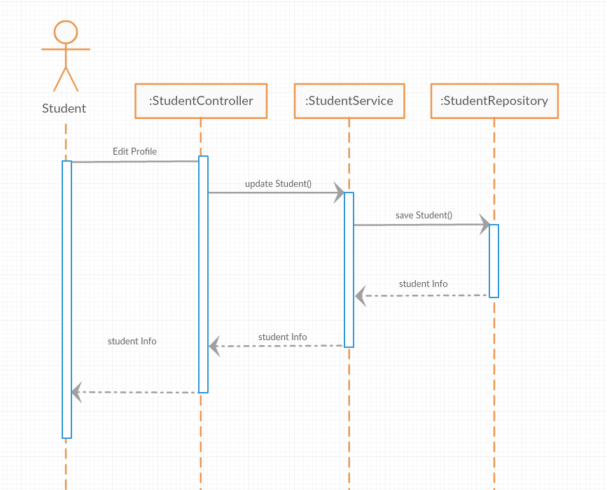

## Class Design

# Data Model

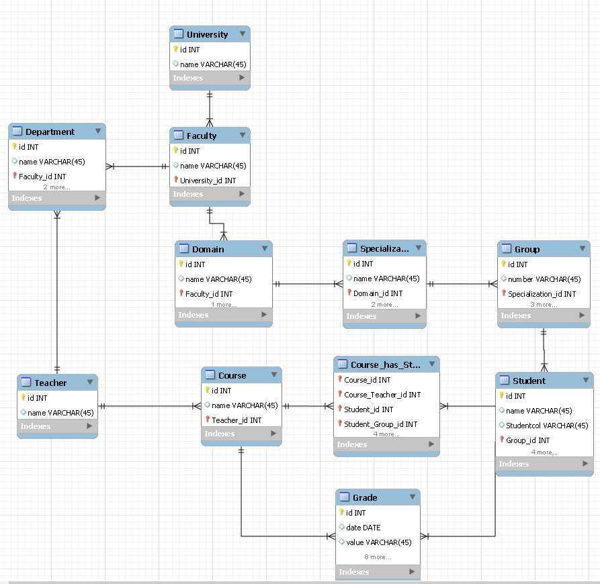

# System Testing

• **Unit testing** is a software testing method by which individual units of source code, sets of one or more computer

program modules together with associated control data, usage procedures, and operating procedures, are tested to determine whether they are fit for use.

• **Graphical user interface testing** is the process of testing a product's graphical user interface to ensure it meets its specifications. This is normally done through the use of a variety of test cases. To generate a set of test cases, test designers attempt to cover all the functionality of the system and fully exercise the GUI itself.

**• Usability testing** is a technique used in user-centered interaction design to evaluate a product by testing it on users. Setting up a usability test involves carefully creating a scenario, or realistic situation, wherein the person performs a list of tasks using the product being tested while observers watch and take notes (dynamic verification).

# Bibliography

[https://msdn.microsoft.com/en-us/library/ee658109.aspx](https://msdn.microsoft.com/en-us/library/ee658109.aspx%20)

[https://www.oreilly.com/ideas/software-architecture-patterns/page/2/layered-architecture](https://www.oreilly.com/ideas/software-architecture-patterns/page/2/layered-architecture%20) <https://en.wikipedia.org/wiki/System_testing>